# Supplemental Tables

**Table S1.** CD spectral properties of ferric WT and mutant CPO in phosphate buffer, pH 5.9 in the heme region ((+), (-), (s) indicate positive and negative signals, and a shoulder in a band, respectively).

|  |  |  |  |  |
| --- | --- | --- | --- | --- |
| **Protein** | **δ band (nm)** | **Soret (nm)** | **CT band (nm)** | **Q bands (nm)** |
| WT CPO | 372(-) | 428(--) | 480(-) | 545(++) |
| R26A CPO | 344(-) | -- | 481(-) | 561(--), 572(--) |
| N33A CPO | 350(-) | 424(--) (s) | -- | 547(+), 559(-), 579(-) |
| R26A/N33A CPO | 345(-) | 420(--) (s) | -- | 575(--), 580(--) |

**Table S2.** Spectral properties of ferrous WT, R26A, N33A, and R26A/N33A CPO and their CO complexes.

|  |  |  |  |
| --- | --- | --- | --- |
| **Protein** | **δ band (nm)** | **Soret (nm)** | **Q band (nm)** |
| WT CPO | -- | 408 | 550 |
| WT-CO | -- | 445 | 550 |
| R26A | -- | 408 | 551 |
| R26A-CO | -- | 444 | 551 |
| N33A | -- | 407 | 551 |
| N33A-CO | 358 | 443 | 551 |
| R26A/N33A | -- | 408 | 550 |
| R26A/N33A-CO | 357 | 444 | 550 |

**Table S3.** Extinction coefficients of oxidized ABTS, MCD, hydrogen peroxide, and styrene.

|  |  |  |
| --- | --- | --- |
| **Substrate or product** | **Wavelength** | **Extinction**  **Coefficient (mM-1cm-**  **1)** |
| Oxidized ABTS | 405 nm | 36.8 |
| MCD | 278 nm | 12.2 |
| H2O2 | 240 nm | 0.0436 |
| Styrene | 262 nm | 0.6225 |

# Supplemental Figures

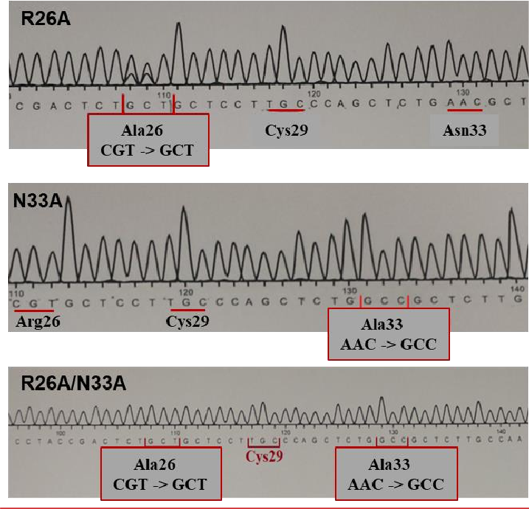

**Figure S1**. DNA sequencing results showing introduced amino acid substitutions (Arg26 and Asn33 were replaced with Ala).

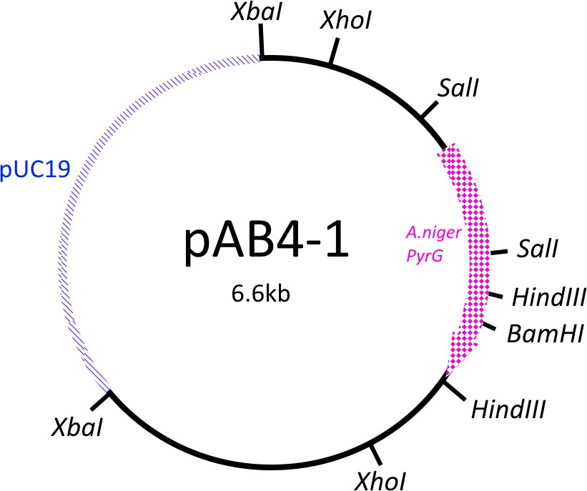

**Figure S2**. pAB4-1 plasmid containing A. niger PyrG gene as a selection marker allowing fungal growth without uridine supplementation.

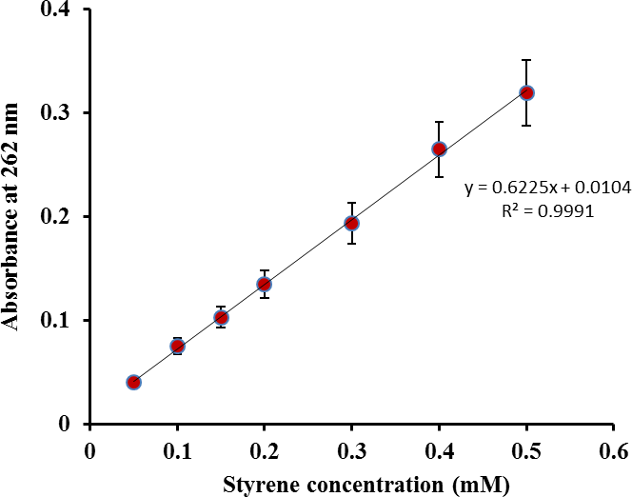

**Figure S3.** A plot of styrene concentration versus absorbance at 262 nm (n=3). Error bars represent standard deviation.