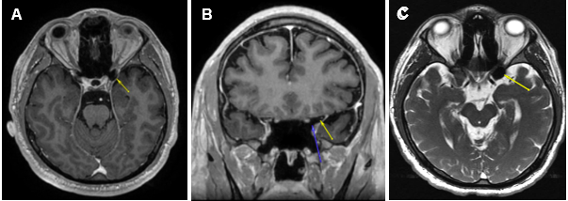
Figure 1. (A) Axial post-gadolinium T1-weighted MRI demonstrating the T1 hypointensity in the left anterior clinoid process (yellow arrow). (B) Coronal post gadolinium T1-weighted MRI with two arrows outlining a clearly delineated air-filled space without a hematoma or traumatic lesion to optic nerve just superior to the tip of blue arrow. (C) Axial T2-weighted FIESTA-C MRI showing T2 hypointensity in the left anterior clinoid process (yellow arrow).

